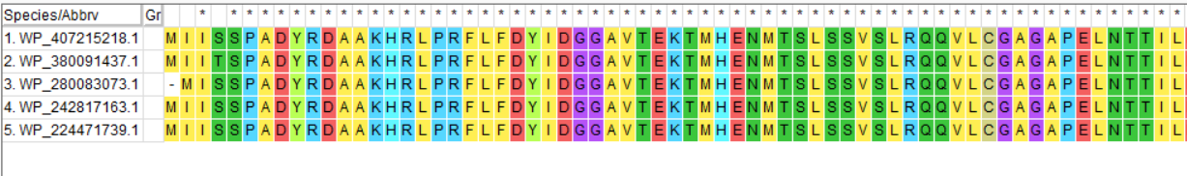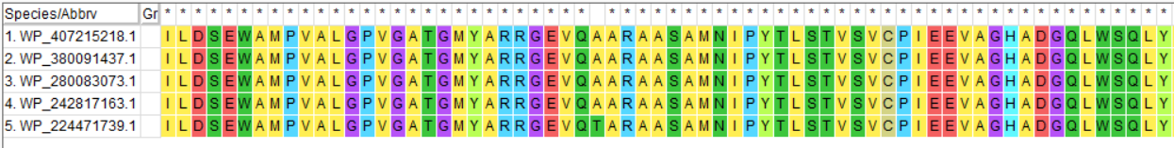
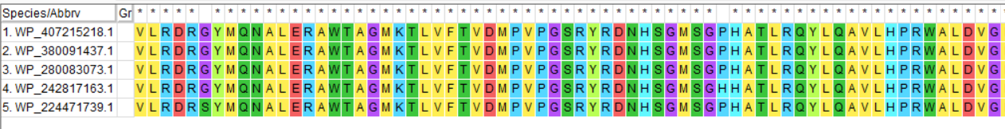
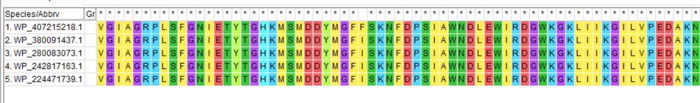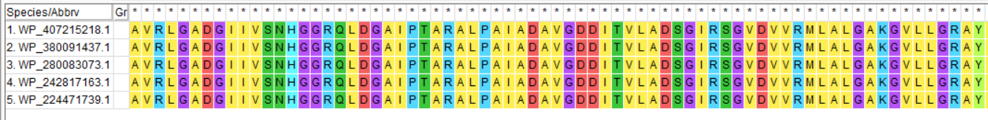
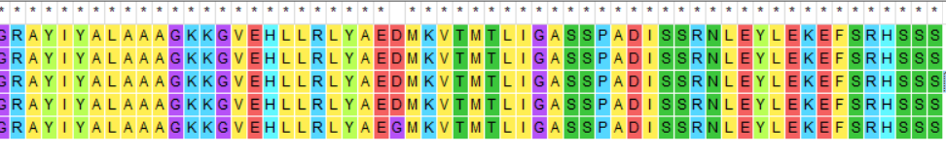
Conserved Regions:
All amino acids are conserved across all 5 sequences.

